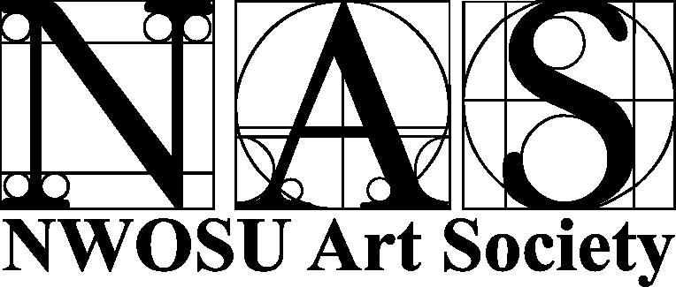
2008 Art Show Winners
STUDENT BEST OF SHOW – Kelsey Harzman, “One Good Coyote”
EMPLOYEE BEST OF SHOW – Rod Murrow, “Ear on the Track”
PEOPLE’S CHOICE WINNER – Rod Murrow, “Great Salt Plains Lake”
CELEBRATE NORTHWESTERN WINNERS
1. Kristy San Soucie, “Fine Arts Falls into Line”
2. Rod Murrow, “Herod Hall”
3. Valarie Case, “The Ranger”
PHOTO/DIGITAL ART – DIVISION WINNER  Kelsey Harzman – One Good Coyote | PHOTO/DIGITAL ART - DIVISION WINNER  Rod Murrow – Ear to the Track
BLACK AND WHITE
STUDENTS |  | EMPLOYEES
1. Andrew Lauffer – As Long as Waters Flow  2. Kelsey Harzman – Who Are You Looking At?  3. Brooke Butler – Wash Up |  | 1. Rod Murrow – Ear to the Track  2. Lois Hudgins – Abandoned  3. Lois Hudgins – Winter Crossroads
LIFE
1. Kelsey Harzman – Puppy Love  2. Rachel Soliz – In Awe..  3. Amy Lu Riley – Beastly Kisses |  | 1. Valarie Case – Tuba Time  2. Lois Hudgins – On the Alert  3. Valarie Case – Blow Those Horns
OUTDOOR BEAUTY
1. Kelsey Harzman – One Good Coyote  2. Andrew Lauffer – Grave Home  3. Kyler Baum – Shunned |  | 1. Rod Murrow – That Grand Old Tree  2. Lois Hudgins – Sun Worshipper  3. Rod Murrow – Great Salt Plains Lake
ELEMENTS OF DESIGN
1. Andrew Lauffer – The Eyes of Geghard  2. Lakin Ragains -- Gleaner  3. Kelsey Harzman – Ice Sickle Windmill |  | 1. Valarie Case – Capitol Columns  2. Rod Murrow – Ice & Snow  3. Angelia Case -- Stairs
RANGER SURPRISE
1. Lakin Ragains – Uncle Raymond’s Place  2. Kelsey Harzman – Bubbles  3. Ashley Ottensmeier – All Played Out |  | 1. Lois Hudgins – Ole  2. Rod Murrow – Maytag  3. Lois Hudgins – Colorful Character
DIGITAL DARKROOM
1. Lakin Ragains – Monkey Business  2. Lakin Ragains – Mask  3. Kelsey Harzman – Emilee |  | 1. Lois Hudgins -- Iris  2. Valarie Case – The Woven Tower  3. Valarie Case – Ranger Spirit
3-D/FUNCTIONAL ART DIVISION WINNER  Kristy San Soucie – Americana Blanket |  | 3-D/FUNCTIONAL ART DIVISION WINNER  LOIS HUDGINS - Bocote
FIBER ART
1. Kristy San Soucie – Americana Blanket  2. Kasey Fowler – Spice  3. Kasey Fowler – Sugar |  | 1. Sheila Brintnall – Floral Star  2. Pam Davidson – Flower  3. Pam Davidson – Pineapple Swirl
DESIGNER ARTS/JEWELRY
1. Kasey Fowler – Green Stone Bracelet  2. Kasey Fowler – Flat Top Ring |  | 1. NA  2. NA
DECORATIVE PAINTING
1. Kristy San Soucie – Wooden Cross |  | 1. NA
FUNCTIONAL ART
1. NA  2. NA  3. NA |  | 1. Lois Hudgins – Bocote  2. Lois Hudgins – Holey Cow  3. Ronnie Walker – Candy bowl
PAINTING & GRAPHICS – DIVISION WINNER  Catherine Wells - Skillet |  | PAINTING & GRAPHICS – DIVISION WINNER  Angelia Case - Willie
OIL
1. Catherine Wells -- Skillet  2. Catherine Wells -- Field |  | 1. NA  2. NA
ACRYLIC
1. Leslie Apodaca -- Reflection  2. Leslie Apodaca -- Artic |  | 1. NA  2. NA
WATERCOLOR
1. Kristy San Soucie – Seasonal Leaves  2. Ashley Carter – Floatin’ Down the River |  | 1. NA  2. NA
PASTEL
1. Ashley Carter – Freedom  2. Leslie Apodaca – Eyes Are Watching You  3. Karen Rhymer – Blue-Eyed Cat |  | 1. NA  2. NA  3. NA
PENCIL
1. Kelsey Harzman – Mother to Be  2. Catherine Wells – A Father’s Love  3. Ashley Carter -- Morgan |  | 1. Angelia Case -- Willie  2. NA  3. NA
PEN & INK
1. Ashley Carter -- Zebra |  | 1. NA
MIXED MEDIA
1. Leslie Apodaca – High Five  2. Karen Rhymer – Black and White Puppy  3. Leslie Apodaca -- Ape |  | 1. NA  2. NA  3. NA

