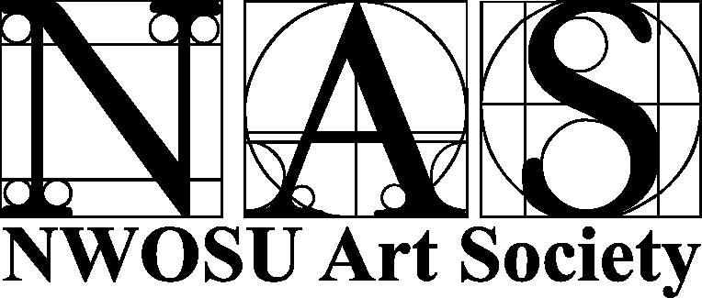
2006 Art Show Winners
STUDENT BEST OF SHOW – Mike Wagar, “Eagle”
EMPLOYEE BEST OF SHOW – Jerry Brownrigg, “Mesquite Vase”
PEOPLE’S CHOICE WINNER – B.J. Taylor, “Sherri”
TEXTILES DIVISION WINNER  KRISTY BAUMAN – Baby Afghan | TEXTILES DIVISION WINNER  CINDY SMITH – Old Santa
QUILTING
STUDENTS |  | EMPLOYEES
1. --  2. -- |  | 1. Tami Cooper – Aunt Mae’s Scrappy Quilt  2. Tami Cooper – 70’s Turning Twenty
NEEDLEWORK

1. Kristy Bauman – Baby Afghan  2. – |  | 1. Cindy Smith – Old Santa  2. Cindy Smith -- Indian
PHOTOGRAPHY DIVISION WINNER:  KAYTE ANTON -- Remembrance |  | PHOTOGRAPHY DIVISION WINNER:  VALARIE CASE -- New York in February
PHOTO - FILM
1. Nichole Kelleher – Junkyard Finds  2. Jonathon Goforth – Elwood’s Fear  3. Nicholle Kelleher -- Shadows |  | 1. Monica Park – Pearl Harbor: In Honor of Reagan  2. Monica Park -- Postcard  3. --
PHOTO - DIGITAL
1. Kayte Anton -- Remembrance  2. Kayte Anton -- Beginnings  3. Helena Plett – Red Rocks |  | 1. Valarie Case – New York in February  2. Monica Park – 3,000 Words  3. Janet Valencia – Diploma/Ring
DIGITAL ART
1. Nicholle Kelleher -- rEVOLUTION  2. Nicholle Kelleher – Eye of the Beholder  3. Bradley Gilbert – Resting Geese |  | 1. Monica Park -- Announcement  2. Rod Murrow – Old House  3. Lois Hudgins – A Rose by Any Other Name
3-D/FUNCTIONAL DIVISION WINNER:  MIKE WAGAR -- Eagle |  | 3-D/FUNCTIONAL DIVISION WINNER:  JERRY BROWNRIGG – Mesquite Vase
SCULPTURE
1. Mike Wagar -- Eagle  2. Kiera Brunson – Rock in Stone  3. Mike Wagar – Gun Stock |  | 1. Jerry Brownrigg - Mesquite Vase  2. Fred Riggins -- Monk  3. Fred Riggins – Progression: Embryo, Woman with Child, Man
JEWELRY
1. Kiera Brunson -- Star  2. Kiera Brunson – Winded Turquoise |  | 1. --  2. --
DECORATIVE PAINTING
1. –  2. –  3. -- |  | 1. Jerry Brownrigg – Box Elder Vase  2. Cindy Gottsch – Millennium Santa  3. Fred Riggins – Autumn Majesty
FUNCTIONAL ART
1. Ronnie Walker – Salad Bowl  2. Nick Lyon – Bloodwood Darts  3. Ronnie Walker – Peanut Bowl |  | 1. Jerry Brownrigg – Mesquite Platter  2. Lois Hudgins – Bowl  3. Shirley Murrow – Daffodils in Bloom
PAINTING DIVISION WINNER:  KIERA BRUNSON – We All Come Falling Down |  | PAINTING DIVISION WINNER:  MAX RIDGWAY – Premonition of a Dream
OIL
1. Kiera Brunson – We All Come Falling Down  2. Kristy Bauman – Tetradic Swirls  3. Kiera Brunson – Depression in the Distance |  | 1. –  2. –  3. --
ACRYLIC
1. B.J. Taylor -- Kenya  2. Carlinda Carmack – Flowers in Whimsy  3. Jeremiah Stewart – A Growing Past |  | 1. Max Ridgway -- Improvisation  2. --  3. ---
WATERCOLOR
1. Carlinda Carmack – Spring in Watercolor  2. Kiera Brunson – Watching Men Go By  3. Kiera Brunson -- I Want To Be Like Dad |  | 1. Max Ridgway – Premonition of a Dream  2. Max Ridgway – Symbols of Transformation  3. --
GRAPHICS DIVISION WINNER:  CATHERINE WELLS – Untitled (pencil) |  | GRAPHICS DIVISION WINNER:  ANGELIA CASE – Daisy
PASTEL
1. Kiera Brunson – Study of Dali’s Composition of Drawers  2. Zenita Kayastha – Musical Instruments  3. Kiera Brunson – Encaged Freedom |  | 1. --  2. –  3. --
PENCIL
1. Catherine Wells -- Untitled  2. B.J. Taylor -- Sherri  3. Anika Brandt -- Freedom |  | 1. Angelia Case -- Daisy  2. –  3. --
PEN & INK
1. B.J. Taylor – RIP James  2. B.J. Taylor – Best Friends  3. Jeremiah Stewart -- Saporagen |  | 1. –  2. –  3. --
MIXED MEDIA
1. Catherine Wells -- Untitled  2. Kiera Brunson – Aye ‘N’ Nye  3. Kiera Brunson -- Intraption |  | 1. Valarie Case -- Random Symmetry  2. Monica Park – Pride and Boy  3. Max Ridgway – Five Scenes from the Book of Secrets

